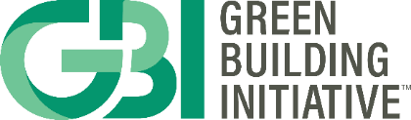

GBI’s New Construction Subcommittee Membership Application

Note: This form is for individuals who would like to participate in the continuance maintenance process of the ANSI/GBI 01-2021 (NC) standard. Members participating in GBI's New Construction consensus process may also participate in our Existing Buildings process, including sitting on Subcommittees. Subcommittees may review task group proposals and/or be asked by the Consensus Body to review proposals.

PART I. GENERAL INFORMATION

Name:
Title:
Company:
City: |  | State/Province:
Direct phone: |  | Ext.: |  | Mobile:  (preferred)
Email:

PART II. REQUEST FOR SUBCOMMITTEE MEMBERSHIP

If you are interested in actively participating on a Subcommittee, please answer questions 1-3 below. Attach a résumé or additional sheets as necessary.

- Indicate one or more Subcommittees ranked by preference (1 is most interested in serving through 6):

____ Project Management

____ Site

____ Energy

____ Water Efficiency

____ Materials

____ Indoor Environment

- State why you wish to become a Subcommittee member and describe your specific interest in the standard/section(s) you have selected.

- Provide evidence of expertise in areas relevant to the Subcommittee(s) for which you have indicated your interest.

PART III. SIGNATURE

An application is not complete without submitting a signed Green Building Initiative Code of Conduct form at https://www.thegbi.org/ansi. I attest that the information provided in this form is true and accurate.

Signature: |  | Date:

Email Completed Form to: Emily Marx, emarx@thegbi.org

For questions please contact Emily Marx, Manager of Standards and Program Support, at emarx@theGBI.org or 503.274.0448 x103.

