BSR/GBI 01-201X

The twenty second meeting of the
GBI 01-201X Consensus Body will be held by Webinar/Teleconference
Part I: Tuesday, August 16th
Part II: Wednesday, August 17th
11:00 AM to 3:00 PM Eastern Time

- MEETING NOTICE -

Webinar/teleconference access information
to be emailed prior to the meeting

The purpose for this teleconference is for Consensus Body members to review recommended responses to comments from the public comment period for the Working Draft of 01-201X document and questions/comments from the public.

The tentative agenda will be posted on the GBI webpage for the standard at: http://www.thegbi.org/ansi. All meetings are open to the public. Any member of the public or Subcommittee participant who would like to attend the meeting should contact the Secretariat Maria Woodbury preferably at least 10 days in advance of the meeting to ensure they are included in relevant communications in preparation for the meeting.

TO ATTEND, AND FOR ADDITIONAL INFORMATION, PLEASE CONTACT:

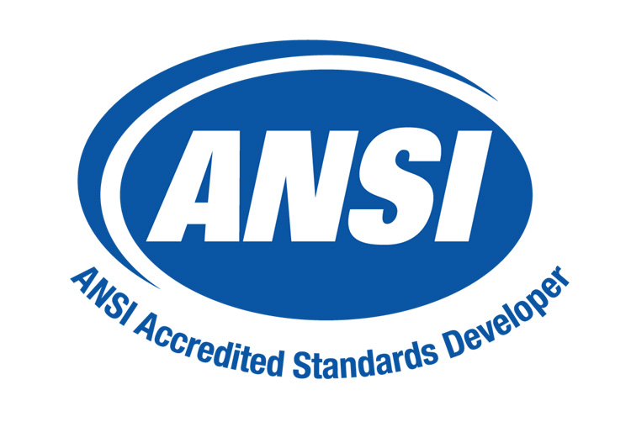
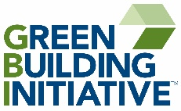
Maria Woodbury
Secretariat for GBI
Green Building Initiative
207-807-8666 (direct)
maria@thegbi.org

